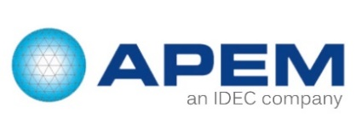

INSIDE SALES / PRODUCT SPECIALIST | BENELUX
Do you have a technical background with a first sales and/or support experience ? Do you want to become an Inside Sales Product Specialist for the Benelux ?

Inside Sales & Product Specialist: The position
Because of expansion, Apem Benelux is looking for an Inside Sales Product Specialist. Based in the APEM Benelux office in Zaventem, the Inside Sales Product Specialist will support the account managers and the distribution network of the Benelux area.
In his/her inside sales role, the candidate will do a telephone follow-up of customers/prospects and quotations, assess their needs and report to the account managers. Marketing actions such as contacting prospects to introduce the APEM-IDEC brand and local exhibition support is a part of his/her role. When interesting, he/she will arrange an appointment for the account manager to visit the customer.
In his/her role as a product specialist, he/she will take care of customer requests and support the account managers on a range of APEM HMI and IDEC automation products. A regular contact with the Global Product Managers for each of the product lines ensures all necessary support. Through product trainings the candidate will become a product specialist for these product lines.
A technical support with the account managers at the customers’ premises to define the right technical solution against every request may also apply.
The product specialist will regularly perform product trainings at the distributors’ offices and inform them through product launches on the latest product releases.

Inside Sales Product Specialist: Your profile
- Bachelor degree in automation or electromechanical engineering or similar through proven experience
- Competent in the understanding and application of machines
- Very good knowledge of Dutch, fluency in English, practical knowledge of French

Apem: The company
APEM, founded in 1952 and part of IDEC, has become one of the leading worldwide manufacturers of Human machine interfaces. The group is present in 11 countries and has a network of more than 130 distributors and agents on five continents. With production plants in Europe, America, Asia and North Africa, APEM achieves 67 % of its turnover from export markets.
APEM develops and manufactures professional switch products for diversified markets including instrumentation, medical, communications, industrial automation, defence and transport.

Inside Sales Product Specialist: Our offer
- Innovative company with a familiar atmosphere in the BNLX and part of a big international group
- High technical level and customized products
- Possibility to grow within the Benelux team and work in an international environment

